OFFICIAL COORDINATION REQUEST FOR
NON-ROUTINE OPERATIONS AND MAINTENANCE

COORDINATION TITLE- 25JDA01 – SFL 2-Fish Turbine Operation and Floating Orifice Gate Removals
COORDINATION DATE- 2/6/25
PROJECT- John Day Dam
RESPONSE DATE- 2/20/25

Description of the problem - The John Day South fishway (SFL) has an auxiliary water supply powered by three turbines that feed attraction water to the SFL entrances. Excessive vibrations, due to worn guide bearings, have been documented on south fish turbine (SFT) #1 and SFT #2 for several years. These vibrations make it necessary to run the units at reduced RPMs (55-RPMs instead of the maximum 68-RPMs). In order to preserve the life of these units, JDA has been running only one of these units, while using the other unit as an emergency backup (see 24JDA01). Currently SFT #1 and #2 are in the planning phase of major overhauls, making it infeasible to acquire additional funding for immediate repairs. SFT #3 is fully operational.

The FPP states “if one turbine fails, increase the output of the two remaining turbines to meet adult fishway criteria” (3.2.4.1.a.). Since SFT #1 and #2 can only be run at reduced RPMs, this will not be possible. Therefore, personnel are requesting to operate the SFL in a modified 1-turbine operation (3.2.4.1.b). Either SFT #1 or SFT #2 will be running at reduced RPMs while SFT #3 runs throughout the season. All entrance weirs will be open at 8’ (instead of closing NE-1), and the floating submerged orifice gates (FOGs) will be closed. This should allow for adequate attraction flow to the SFL while also leaving one SFT available for backup. This is the same operation that was used for the 2024 fish passage season (see 24JDA01) when the SFL remained in criteria throughout the entire season.

Type of outage required – FOGs will be removed for 2025 similar to the 2024 adult passage season. The additional water savings will aid in decreasing the output of the SFTs and will help by decreasing any degradation to the unit’s pump assemblies, which are in poor shape and at risk of total failure.

Impact on facility operation – There will be minimal impacts to facility operation. However, removing the FOGs will allow the remaining SFL entrances to run in criteria while also freeing up one of the turbines to function as a backup.

Dates of impacts/repairs – Unknown, the work to repair SFT #1 and #2 are running through contracting.

Length of time for repairs – Unknown, as stated earlier SFT #1 & #2 are in the planning phase of a major overhaul with no set repair dates.

Analysis of potential impacts to fish- There appeared to be an increase in NFL usage for 2024 when compared to previous years (Figure 1). This may be correlated to the SFL modified operations, changes in spring spill operations since 2018, a combination of the two, or merely an outlier year.

The entrance/tailwater differentials, velocities, and the weir depths throughout the 2024 passage season were in criteria. The only deviation from the FPP was that the FOGs were removed creating fewer entrances into the SFL collection channel. However, it should be noted that the SFL criterias were at or just below the minimum acceptable levels. The entrance/tailwater differential was essentially 1.0’ for the duration of the season (1.0’ – 2.0’ is the criteria), the depth of the south entrance was at or just deeper than 8.0’ (8.0’ is the minimum depth), and the velocities were consistently on the low side of criteria (1.5’ – 4.0’/second). Having the FOGs installed would have likely led to numerous OOC instances.

For the 2018 – 2023 fish passage seasons, spring spill operations consisted of spilling water to the gas cap. This greatly increased the amount of spill and could have masked attraction flows to the NFL. A reduction in attraction to the NFL may have led to higher attraction to the SFL.

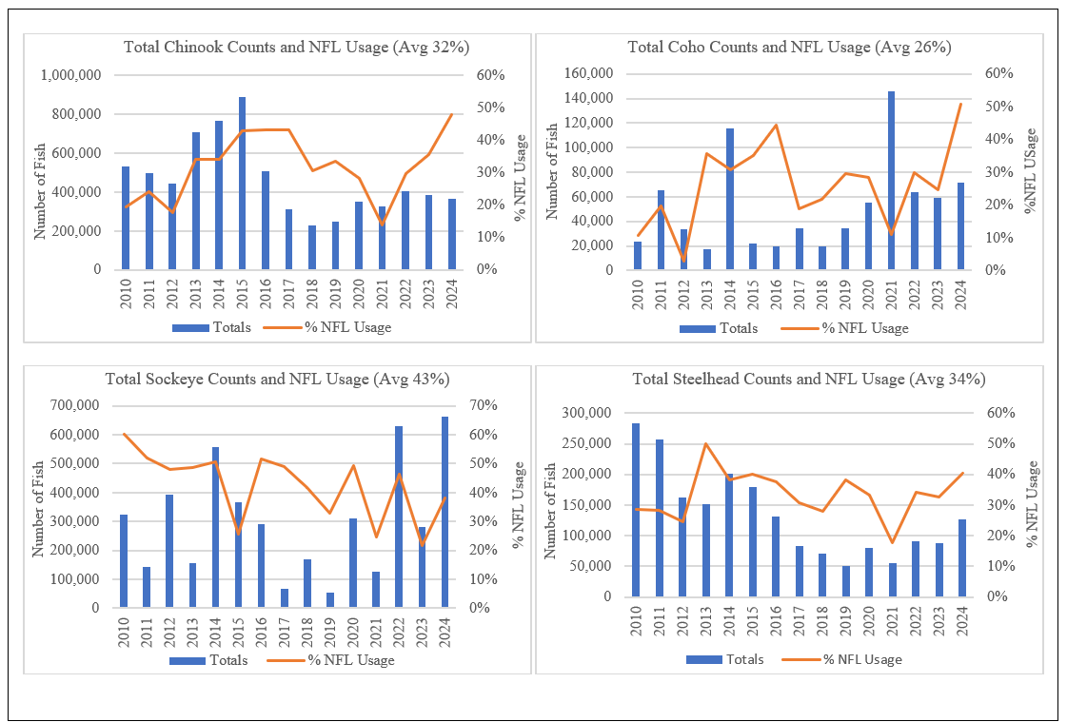
Figure 1: Ladder usage for 4-salmonid species at JDA (Chinook, coho, sockeye, and steelhead). It should be noted that while the SFL was able to maintain FPP guidelines. These guidelines were typically at the bare minimum for the duration of the season. The entrance differential was around 1.0’ for the duration of the season (1.0’ – 2.0’ is criteria) and the weir depth was just above 8.0’ for the duration of the season (8.0’ is the minimum acceptable depth).

Summary statement – expected impacts on:

Downstream migrants: There is no expected impact to downstream migrants.

Upstream migrants (including Bull Trout): The entrance weirs and their entrances will be kept in FPP ranges.

Lamprey: The entrance weirs and their entrances will be kept in FPP ranges.

The condition of South fish turbine pumps 1 & 2 gives the project no flexibility in maintaining entrance criteria at the ladder entrances if the floating orifices are redeployed.

Comments from agencies

Final coordination results

Please email or call with questions or concerns.
Thank you,

David Miller
Supervisory Fisheries Biologist
John Day/Willow Creek Project
David.L.Miller@usace.army.mil

And

Patricia Madson
NWP Operations Division Fishery Section
Columbia River Coordination Biologist
Patricia.L.Madson@usace.army.mil

